Demo Script (follow these steps) (brackets are for your understanding)
The demo will be a simulation of our model rocket (.obj/.stl files obtained from Rocketry Structural team, mention this, slip it in).

We will demonstrate how a PID loop works using our simulation.
PID stands for Proportional - Integral - Derivative. In our simulation, there exists a loop that constantly takes inputs from the model rocket’s onboard computer (IRL, not in our simulation) and uses it to measure changes in angles and modify our thrust vector to counter/account for the change in angle due to the unpredictable external environment. Changes to our trajectory may arise due to some gusts of wind, etc.

In each loop, we account for the current angle, the “Proportion”, the rate of change of angle, i.e. the “Derivative” and the accumulation of changes in the angle, i.e. the “Integral” before changing our thrust accordingly.
at this point you start talking about the simulation

We use Unity, a game engine, for its physics to simulate the environment around the model rocket, a launch system with launch rods along with the rocket itself. Using our simulation we can show how different our trajectories differ from having PID turned on and off. Our trajectory in the simulation is a basic one where the model starts off at 0 degrees and eventually reaches a 14 degrees flight path.

“S” for start/stop PID loop (begin with the PID turned on)
”D” for disturbance, (give a small disturbance) (make sure you point towards the effort the PID loop makes to account for the disturbance).

Multiple disturbances, causes the model to go on an uncontrolled flight path, despite having the PID loop turned on. With the PID loop turned off, even a single disturbance sets the model in an uncontrolled flight path.

Turn off PID and show how disturbances are handled.

“R” for resetting the model to the start
Our future aspects are to use reinforcement learning to determine the weights in the PID loop.

You see, for each of the P I D, there exists a constant that determines how aggressively we counter each variable.

In our simulation we have a fixed set of constants for these weights. What we want to do is to use RL (reinforcement learning) Language models, to train the model into dynamically changing these weights mid-flight.

How we achieve this is by punishing the language model for every failed landing and rewarding the language model for every successful one until it learns to land on its own.

Some questions the viewer might ask:

- What is this? (they actually ask this sometimes)
- This is Rocketry Avionics from SEDS Celestia, we have a simulation that we would like to show you.

- What is this software?
- This is unity, a game engine, games like Hollow Knight, Subnautica are made from this game engine. We however use it to model our physics.
- Why unity?
- It is modular. The other engines like Unreal Engine are used to create better graphics, while unity is simpler.
- What language is used here?
- We use C# for our scripts.

- Why C#?
- It is clean (C++ has complex memory management. It is also a low level language.

- What is a solid angle?
- It's like a regular angle except in 3D, it represents the conical spread/area of the cone pointing away from trajectory.

- What is this and then they point to unity
- Refer to the Unity UI tab.

Unity UI

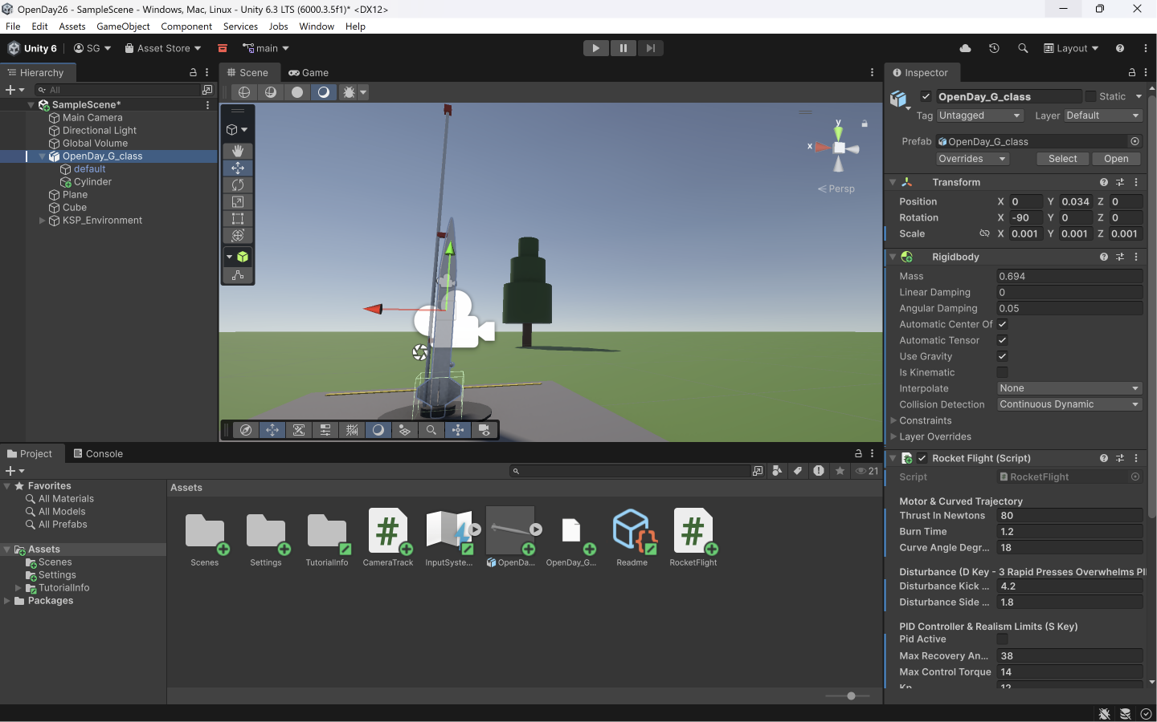
- This is how it looks normally
- Middle click in mouse to Pan
- Right click to observe in a different perspective

- The camera entity is supposed to be where you view from.

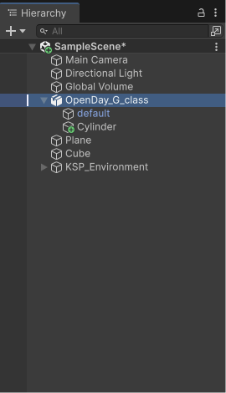
- This is the hierarchy where we add 2D/3D objects into our “Scene”
- A scene is basically a level in a game “of sorts”.

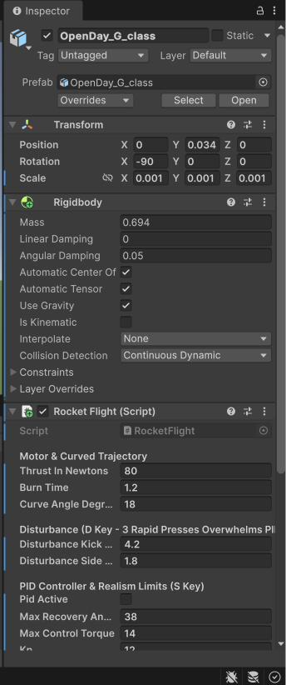
- This is the inspector, it basically allows us to add “Properties” to our objects
- Objects are anything that is added to our scene.
- Properties are to be added to each object
- Examples of Properties are
  - RigidBody: To tell the engine that our object is solid
  - Mesh: To model our boundaries of our object
  - Scripts: You can add scripts to your objects to make them behave a certain way.

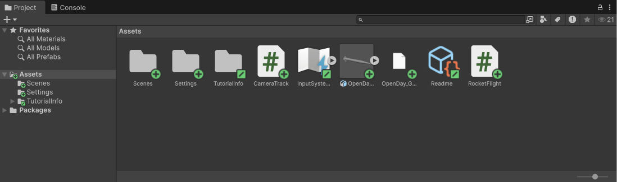
- This is where all our imports come into.
- Our scripts and objects that we import are seen here.

C# Scripts (you don't need to go through this)

Below is the script to model the environment + flames out of the thrusters + launch rod & pad + textboxes for info + trajectory trail + controls

using UnityEngine;
using UnityEngine.InputSystem;
using System.Collections.Generic;

[ExecuteAlways]
public class RocketFlight : MonoBehaviour
{
[Header("Launch Rod Alignment (Threads Through Built-In Lugs!)")]
public float launchRodOffsetX = -0.024f; // Negative X puts the rod on the LEFT side where your model's lugs are!
public float launchRodOffsetZ = 0.0f; // Tweak slightly in Inspector if lugs are slightly forward/back

[Header("Motor & Curved Trajectory")]
public float thrustInNewtons = 16f;
public float burnTime = 25.0f;
public float curveAngleDegrees = 14f;
private float currentBurnTime = 0f;

[Header("Disturbance (D Key - 3 Rapid Presses Overwhelms PID)")]
public float disturbanceKickSpeed = 2.15f;
public float disturbanceSidePush = 0.85f;
private float lastDisturbDir = 1f;
private float lastDisturbTime = -10f;

[Header("PID Controller & Realism Limits (S Key)")]
public bool pidActive = true;
public float maxRecoveryAngle = 34f; // Stalls past 34 degrees!
public float maxControlTorque = 6.5f;
public float Kp = 8.5f;
public float Ki = 0.8f;
public float Kd = 2.6f;

private Rigidbody rb;
private bool isLaunched = false;
private bool isStalled = false;

private Vector3 initialPosition;
private Quaternion initialRotation;
private Vector3 localNoseDirection;
private Vector3 integralError = Vector3.zero;

// Live Telemetry Data
private Vector3 previousVelocity = Vector3.zero;
private float currentSpeed = 0f;
private float currentAcceleration = 0f;
private float currentDeviationAngle = 0f;
private float currentSolidAngleSr = 0f;

// Visuals: Trajectory Line & 3D Exhaust Plume
private LineRenderer trajectoryLine;
private List<Vector3> pathPoints = new List<Vector3>();
private float pointRecordTimer = 0f;

private GameObject flameRoot;
private Transform outerFlame;
private Transform innerCoreFlame;
private Transform launchRodTransform;
private Transform launchRodCapTransform;

void OnEnable()
{
initialPosition = transform.position;
initialRotation = transform.rotation;
BuildKSPEnvironment();
}

void OnValidate()
{
// Live-updates the rod position in the Scene view if you tweak launchRodOffsetX/Z in the Inspector!
UpdateLaunchRodPosition();
}

void Start()
{
initialPosition = transform.position;
initialRotation = transform.rotation;
localNoseDirection = transform.InverseTransformDirection(Vector3.up);

BuildKSPEnvironment();

if (!Application.isPlaying) return;

rb = GetComponent<Rigidbody>();
rb.isKinematic = true;

rb.linearDamping = 0.8f;
rb.angularDamping = 2.5f;

pidActive = true;
burnTime = 25.0f;
thrustInNewtons = 16f;
curveAngleDegrees = 14f;
disturbanceKickSpeed = 2.15f;
disturbanceSidePush = 0.85f;
maxRecoveryAngle = 34f;
maxControlTorque = 6.5f;
Kp = 8.5f;
Ki = 0.8f;
Kd = 2.6f;

MeshCollider[] meshColliders = GetComponentsInChildren<MeshCollider>();
foreach (MeshCollider mc in meshColliders)
{
mc.convex = true;
}

SetupTrajectoryLine();
Setup3DExhaustPlume();
UpdateTrailColor();
}

float GetExactRocketBottomY()
{
Renderer[] renderers = GetComponentsInChildren<Renderer>();
float lowestY = transform.position.y;
bool found = false;
foreach (Renderer r in renderers)
{
if (r is LineRenderer || r is ParticleSystemRenderer) continue;
if (!found || r.bounds.min.y < lowestY)
{
lowestY = r.bounds.min.y;
found = true;
}
}
return found ? lowestY : transform.position.y;
}

void UpdateLaunchRodPosition()
{
GameObject existingEnv = GameObject.Find("KSP_Environment");
if (existingEnv == null) return;

Transform rod = existingEnv.transform.Find("LaunchRodAssembly/ChromeLaunchRod");
Transform cap = existingEnv.transform.Find("LaunchRodAssembly/RedSafetyCap");
float padTopY = GetExactRocketBottomY();

if (rod != null)
rod.localPosition = new Vector3(initialPosition.x + launchRodOffsetX, padTopY + 0.42f, initialPosition.z + launchRodOffsetZ);
if (cap != null)
cap.localPosition = new Vector3(initialPosition.x + launchRodOffsetX, padTopY + 0.85f, initialPosition.z + launchRodOffsetZ);
}

// =========================================================================
// CLEAN KSP ENVIRONMENT (Uses the Rocket's Built-In Left-Side Launch Lugs!)
// =========================================================================
Material CreateEnvMat(Color col)
{
Shader sh = Shader.Find("Universal Render Pipeline/Lit");
if (sh == null) sh = Shader.Find("Standard");
if (sh == null) sh = Shader.Find("Sprites/Default");
Material m = new Material(sh);
m.color = col;
if (m.HasProperty("_BaseColor")) m.SetColor("_BaseColor", col);
if (m.HasProperty("_Smoothness")) m.SetFloat("_Smoothness", 0.15f);
return m;
}

GameObject MakePart(PrimitiveType type, Transform parent, Vector3 pos, Vector3 scale, Quaternion rot, Material mat)
{
GameObject go = GameObject.CreatePrimitive(type);
if (Application.isPlaying)
Destroy(go.GetComponent<Collider>());
else
DestroyImmediate(go.GetComponent<Collider>());

go.transform.SetParent(parent, false);
go.transform.localPosition = pos;
go.transform.localScale = scale;
go.transform.localRotation = rot;
go.GetComponent<Renderer>().sharedMaterial = mat;
return go;
}

[ContextMenu("Rebuild KSP Environment")]
public void BuildKSPEnvironment()
{
GameObject oldPlane = GameObject.Find("Plane");
if (oldPlane != null && oldPlane.GetComponent<Renderer>() != null)
oldPlane.GetComponent<Renderer>().enabled = false;
GameObject oldCube = GameObject.Find("Cube");
if (oldCube != null && oldCube.GetComponent<Renderer>() != null)
oldCube.GetComponent<Renderer>().enabled = false;

GameObject existingEnv = GameObject.Find("KSP_Environment");
if (existingEnv != null)
{
if (existingEnv.transform.Find("BuiltInLugMarker") != null)
{
UpdateLaunchRodPosition();
return;
}
if (Application.isPlaying) Destroy(existingEnv);
else DestroyImmediate(existingEnv);
}

GameObject env = new GameObject("KSP_Environment");
GameObject marker = new GameObject("BuiltInLugMarker");
marker.transform.SetParent(env.transform, false);

float padTopY = GetExactRocketBottomY();
float grassY = padTopY - 0.08f;

Material grassMat = CreateEnvMat(new Color(0.28f, 0.48f, 0.18f));
Material concreteMat = CreateEnvMat(new Color(0.38f, 0.40f, 0.42f));
Material darkSteelMat = CreateEnvMat(new Color(0.20f, 0.22f, 0.24f));
Material chromeRodMat = CreateEnvMat(new Color(0.82f, 0.86f, 0.90f));
Material clampRedMat = CreateEnvMat(new Color(0.78f, 0.15f, 0.12f));
Material yellowLineMat = CreateEnvMat(new Color(0.85f, 0.72f, 0.15f));
Material trunkMat = CreateEnvMat(new Color(0.32f, 0.21f, 0.12f));
Material pineMat = CreateEnvMat(new Color(0.14f, 0.32f, 0.12f));
Material rockMat = CreateEnvMat(new Color(0.36f, 0.37f, 0.39f)); // Fixed typo here!
Material snowMat = CreateEnvMat(new Color(0.92f, 0.95f, 0.98f));
Material cloudMat = CreateEnvMat(new Color(0.95f, 0.97f, 1.0f));

// 1. Vast Green Valley Floor
MakePart(PrimitiveType.Cube, env.transform, new Vector3(0f, grassY - 0.5f, 0f), new Vector3(1500f, 1f, 1500f), Quaternion.identity, grassMat);

// 2. Clean Concrete Launchpad Platform (Flush on the ground, no ramp, no extra pillars)
Vector3 padCenter = new Vector3(initialPosition.x, padTopY - 0.04f, initialPosition.z);
MakePart(PrimitiveType.Cube, env.transform, padCenter, new Vector3(0.85f, 0.08f, 0.85f), Quaternion.identity, concreteMat);

MakePart(PrimitiveType.Cylinder, env.transform, new Vector3(initialPosition.x, padTopY + 0.002f, initialPosition.z), new Vector3(0.26f, 0.004f, 0.26f), Quaternion.identity, darkSteelMat);
MakePart(PrimitiveType.Cylinder, env.transform, new Vector3(initialPosition.x, padTopY + 0.012f, initialPosition.z), new Vector3(0.08f, 0.012f, 0.08f), Quaternion.identity, darkSteelMat);

MakePart(PrimitiveType.Cube, env.transform, new Vector3(initialPosition.x, padTopY + 0.001f, initialPosition.z - 0.36f), new Vector3(0.72f, 0.004f, 0.02f), Quaternion.identity, yellowLineMat);
MakePart(PrimitiveType.Cube, env.transform, new Vector3(initialPosition.x, padTopY + 0.001f, initialPosition.z + 0.36f), new Vector3(0.72f, 0.004f, 0.02f), Quaternion.identity, yellowLineMat);

// 3. Single Chrome Launch Rod (Positioned on the LEFT side [-X] to thread right through your STL's built-in launch lugs!)
GameObject rodGroup = new GameObject("LaunchRodAssembly");
rodGroup.transform.SetParent(env.transform, false);

float rodX = initialPosition.x + launchRodOffsetX;
float rodZ = initialPosition.z + launchRodOffsetZ;

GameObject rodObj = MakePart(PrimitiveType.Cylinder, rodGroup.transform, new Vector3(rodX, padTopY + 0.42f, rodZ), new Vector3(0.005f, 0.42f, 0.005f), Quaternion.identity, chromeRodMat);
rodObj.name = "ChromeLaunchRod";

GameObject capObj = MakePart(PrimitiveType.Cube, rodGroup.transform, new Vector3(rodX, padTopY + 0.85f, rodZ), new Vector3(0.014f, 0.014f, 0.014f), Quaternion.identity, clampRedMat);
capObj.name = "RedSafetyCap";

// 4. Scattered Pine Trees Across the Valley
Random.State oldState = Random.state;
Random.InitState(42);
for (int i = 0; i < 85; i++)
{
float tx = Random.Range(-45f, 65f);
float tz = Random.Range(-5f, 95f);
if (Mathf.Abs(tx) < 3.5f && Mathf.Abs(tz) < 4.5f) continue;

float scale = Random.Range(0.7f, 1.5f);
Vector3 tPos = new Vector3(tx, grassY, tz);

MakePart(PrimitiveType.Cylinder, env.transform, tPos + new Vector3(0f, 0.25f * scale, 0f), new Vector3(0.12f * scale, 0.25f * scale, 0.12f * scale), Quaternion.identity, trunkMat);
MakePart(PrimitiveType.Cylinder, env.transform, tPos + new Vector3(0f, 0.55f * scale, 0f), new Vector3(0.65f * scale, 0.25f * scale, 0.65f * scale), Quaternion.identity, pineMat);
MakePart(PrimitiveType.Cylinder, env.transform, tPos + new Vector3(0f, 0.90f * scale, 0f), new Vector3(0.48f * scale, 0.25f * scale, 0.48f * scale), Quaternion.identity, pineMat);
MakePart(PrimitiveType.Cylinder, env.transform, tPos + new Vector3(0f, 1.22f * scale, 0f), new Vector3(0.28f * scale, 0.22f * scale, 0.28f * scale), Quaternion.identity, pineMat);
}

// 5. Snow-Capped Mountain Ridge
int numPeaks = 22;
for (int i = 0; i < numPeaks; i++)
{
float t = (float)i / (numPeaks - 1);
float mx = Mathf.Lerp(-95f, 115f, t);
float mz = Mathf.Lerp(95f, 65f, t) + Random.Range(-8f, 8f);
float mHeight = Mathf.Lerp(14f, 42f, t) + Random.Range(-3f, 5f);
float mWidth = Random.Range(18f, 28f);

Quaternion mRot = Quaternion.Euler(Random.Range(-8f, 8f), Random.Range(0f, 45f), Random.Range(-10f, 10f));
MakePart(PrimitiveType.Cube, env.transform, new Vector3(mx, grassY + mHeight * 0.4f, mz), new Vector3(mWidth, mHeight, mWidth * 0.85f), mRot, rockMat);
MakePart(PrimitiveType.Cube, env.transform, new Vector3(mx, grassY + mHeight * 0.86f, mz - 0.5f), new Vector3(mWidth * 0.82f, mHeight * 0.22f, mWidth * 0.75f), mRot, snowMat);
}

// 6. High-Altitude 3D Clouds
for (int c = 0; c < 35; c++)
{
float cx = Random.Range(-50f, 80f);
float cy = Random.Range(6f, 65f);
float cz = Random.Range(8f, 60f);
float cScale = Random.Range(1.5f, 4.0f);
MakePart(PrimitiveType.Sphere, env.transform, new Vector3(cx, cy, cz), new Vector3(cScale * 2.8f, cScale * 0.6f, cScale * 1.4f), Quaternion.identity, cloudMat);
}
Random.state = oldState;
}

void SetupTrajectoryLine()
{
trajectoryLine = gameObject.GetComponent<LineRenderer>();
if (trajectoryLine == null)
{
trajectoryLine = gameObject.AddComponent<LineRenderer>();
}
trajectoryLine.startWidth = 0.035f;
trajectoryLine.endWidth = 0.015f;
trajectoryLine.material = new Material(Shader.Find("Sprites/Default"));
trajectoryLine.startColor = Color.cyan;
trajectoryLine.positionCount = 0;
}

void Setup3DExhaustPlume()
{
Transform oldParticles = transform.Find("MotorExhaustFlames");
if (oldParticles != null) Destroy(oldParticles.gameObject);

GameObject oldPlume = GameObject.Find("RocketExhaustPlume");
if (oldPlume != null) Destroy(oldPlume);

flameRoot = new GameObject("RocketExhaustPlume");

GameObject outerObj = GameObject.CreatePrimitive(PrimitiveType.Sphere);
Destroy(outerObj.GetComponent<Collider>());
outerObj.transform.SetParent(flameRoot.transform, false);
outerFlame = outerObj.transform;

Renderer outerRen = outerObj.GetComponent<Renderer>();
outerRen.material = new Material(Shader.Find("Sprites/Default"));
outerRen.material.color = new Color(1f, 0.38f, 0.0f, 0.88f);

GameObject innerObj = GameObject.CreatePrimitive(PrimitiveType.Sphere);
Destroy(innerObj.GetComponent<Collider>());
innerObj.transform.SetParent(flameRoot.transform, false);
innerCoreFlame = innerObj.transform;

Renderer innerRen = innerObj.GetComponent<Renderer>();
innerRen.material = new Material(Shader.Find("Sprites/Default"));
innerRen.material.color = new Color(1f, 0.95f, 0.35f, 0.98f);

flameRoot.SetActive(false);
}

void UpdateExhaustPlumeVisuals(Vector3 currentNoseWorld)
{
if (flameRoot == null) return;

bool motorBurning = isLaunched && (currentBurnTime < burnTime);
if (flameRoot.activeSelf != motorBurning)
{
flameRoot.SetActive(motorBurning);
}

if (motorBurning)
{
flameRoot.transform.position = transform.position;
flameRoot.transform.rotation = Quaternion.LookRotation(-currentNoseWorld);

float flicker1 = Random.Range(0.16f, 0.24f);
float flicker2 = Random.Range(0.09f, 0.14f);
float widthJitter = Random.Range(0.032f, 0.042f);

outerFlame.localScale = new Vector3(widthJitter, widthJitter, flicker1);
outerFlame.localPosition = new Vector3(0f, 0f, flicker1 * 0.45f);

innerCoreFlame.localScale = new Vector3(widthJitter * 0.6f, widthJitter * 0.6f, flicker2);
innerCoreFlame.localPosition = new Vector3(0f, 0f, flicker2 * 0.4f);
}
}

void UpdateTrailColor()
{
if (trajectoryLine == null) return;

if (isStalled)
trajectoryLine.endColor = Color.red;
else if (pidActive)
trajectoryLine.endColor = Color.green;
else
trajectoryLine.endColor = new Color(1f, 0.45f, 0f);
}

void FixedUpdate()
{
if (!Application.isPlaying || !isLaunched) return;

currentBurnTime += Time.fixedDeltaTime;

float curveProgress = Mathf.Clamp01((currentBurnTime - 0.3f) / 3.5f);
float currentTargetAngle = curveProgress * curveAngleDegrees;
Vector3 targetTrajectoryDir = Quaternion.Euler(0f, 0f, -currentTargetAngle) * Vector3.up;

Vector3 currentNoseWorld = transform.TransformDirection(localNoseDirection);

currentSpeed = rb.linearVelocity.magnitude;
currentAcceleration = (rb.linearVelocity - previousVelocity).magnitude / Time.fixedDeltaTime;
previousVelocity = rb.linearVelocity;

currentDeviationAngle = Vector3.Angle(currentNoseWorld, targetTrajectoryDir);
float thetaRad = currentDeviationAngle * Mathf.Deg2Rad;
currentSolidAngleSr = 2f * Mathf.PI * (1f - Mathf.Cos(thetaRad));

if (currentDeviationAngle > maxRecoveryAngle && currentBurnTime > 0.3f)
{
if (!isStalled)
{
isStalled = true;
UpdateTrailColor();
}
}

if (currentBurnTime < burnTime)
{
rb.AddForce(currentNoseWorld * thrustInNewtons, ForceMode.Force);
}

if (currentBurnTime < 0.25f)
{
rb.MoveRotation(initialRotation);
rb.angularVelocity = Vector3.zero;
}
else
{
if (isStalled)
{
Vector3 stallTipTorque = Vector3.Cross(targetTrajectoryDir, currentNoseWorld);
rb.AddTorque(stallTipTorque * 2.4f, ForceMode.Acceleration);
}
else if (pidActive)
{
Vector3 error = Vector3.Cross(currentNoseWorld, targetTrajectoryDir);

integralError += error * Time.fixedDeltaTime;
integralError = Vector3.ClampMagnitude(integralError, 1.0f);

Vector3 derivativeError = -rb.angularVelocity;

Vector3 pidTorque = (Kp * error) + (Ki * integralError) + (Kd * derivativeError);
pidTorque = Vector3.ClampMagnitude(pidTorque, maxControlTorque);
rb.AddTorque(pidTorque, ForceMode.Acceleration);
}
else
{
if (currentDeviationAngle > 2f)
{
Vector3 driftTorque = Vector3.Cross(targetTrajectoryDir, currentNoseWorld);
rb.AddTorque(driftTorque * 1.6f, ForceMode.Acceleration);
}
}
}

pointRecordTimer += Time.fixedDeltaTime;
if (pointRecordTimer >= 0.025f)
{
pointRecordTimer = 0f;
pathPoints.Add(transform.position - currentNoseWorld * 0.15f);
trajectoryLine.positionCount = pathPoints.Count;
trajectoryLine.SetPositions(pathPoints.ToArray());
}
}

void LateUpdate()
{
if (!Application.isPlaying) return;
Vector3 currentNoseWorld = transform.TransformDirection(localNoseDirection);
UpdateExhaustPlumeVisuals(currentNoseWorld);
}

void Update()
{
if (!Application.isPlaying || Keyboard.current == null) return;

if ((Keyboard.current.spaceKey.wasPressedThisFrame || Keyboard.current.wKey.wasPressedThisFrame) && !isLaunched)
{
isLaunched = true;
rb.isKinematic = false;
previousVelocity = Vector3.zero;
pathPoints.Clear();
UpdateTrailColor();
}

if (Keyboard.current.rKey.wasPressedThisFrame)
{
ResetRocket();
}

if (Keyboard.current.dKey.wasPressedThisFrame && isLaunched)
{
float timeSinceLastGust = Time.time - lastDisturbTime;
if (timeSinceLastGust > 2.0f)
{
lastDisturbDir = -lastDisturbDir;
}
lastDisturbTime = Time.time;

rb.angularVelocity += new Vector3(0f, 0f, lastDisturbDir * disturbanceKickSpeed);
rb.AddForce(new Vector3(-lastDisturbDir * disturbanceSidePush, 0f, 0f), ForceMode.VelocityChange);
}

if (Keyboard.current.sKey.wasPressedThisFrame)
{
pidActive = !pidActive;
integralError = Vector3.zero;
UpdateTrailColor();
}
}

void ResetRocket()
{
isLaunched = false;
isStalled = false;
currentBurnTime = 0f;
integralError = Vector3.zero;
pidActive = true;
UpdateTrailColor();

currentSpeed = 0f;
currentAcceleration = 0f;
currentDeviationAngle = 0f;
currentSolidAngleSr = 0f;
previousVelocity = Vector3.zero;

rb.linearVelocity = Vector3.zero;
rb.angularVelocity = Vector3.zero;
rb.isKinematic = true;

transform.position = initialPosition;
transform.rotation = initialRotation;

pathPoints.Clear();
if (trajectoryLine != null) trajectoryLine.positionCount = 0;
if (flameRoot != null) flameRoot.SetActive(false);
}

void OnGUI()
{
if (!Application.isPlaying) return;

GUIStyle style = new GUIStyle(GUI.skin.box);
style.fontSize = 11;
style.fontStyle = FontStyle.Bold;
style.alignment = TextAnchor.MiddleLeft;
style.wordWrap = true;
style.padding = new RectOffset(10, 10, 6, 6);
style.normal.textColor = Color.white;

string statusText;
if (isStalled)
statusText = "<color=#FF3333>STALLED (>34° - Unrecoverable!)</color>";
else if (pidActive)
statusText = "<color=#00FF00>ON (Active Stabilization)</color>";
else
statusText = "<color=#FF9900>OFF (Unguided Flight)</color>";

string degColor = isStalled ? "#FF3333" : (currentDeviationAngle > 18f ? "#FFFF00" : "#00FFFF");

string info = $"ROCKET AVIONICS & TELEMETRY\n" +
$"PID Loop [S]: {statusText}\n" +
$"Velocity: <color=#00FFFF>{currentSpeed:F1} m/s</color> | Accel: <color=#00FFFF>{currentAcceleration:F1} m/s²</color>\n" +
$"Trajectory Deviation: <color={degColor}>{currentDeviationAngle:F1}°</color> (Solid Angle: <color={degColor}>{currentSolidAngleSr:F3} sr</color>)\n" +
$"Controls: [Space] Launch | [D] Wind Gust | [R] Reset";

GUI.Box(new Rect(25, 12, 380, 92), info, style);
}
}
Below is the script for the camera to follow our model rocket:
using UnityEngine;

public class CameraTrack : MonoBehaviour
{
public Transform rocket;
private Vector3 offset;

void Start()
{
if (rocket != null)
{
// Lock onto the rocket and step back slightly so we see the rocket + trail clearly
offset = new Vector3(0f, 0.25f, -2.5f);
transform.rotation = Quaternion.Euler(0f, 0f, 0f);
}
}

void LateUpdate()
{
if (rocket != null)
{
// Exact position lock so the rocket NEVER flies out of the camera view!
transform.position = rocket.position + offset;
}
}
}

